How is Global Warming Effecting the Environment?

Suvam Patel

University of California, Irvine

**Introduction**

Climate Change is a byproduct of human practices. Our increasing demand of energy and natural resources is degrading the environment of the planet. Such degradation can really hinder our ability to survive in the future. To understand how climate change will affect the environment, I decided to research how the rising surface air temperature trend will affect evapotranspiration rates and soil moisture content globally. It is imperative to foresee the consequences of increasing human demands, so that we can understand the impact of our habits. Evapotranspiration rate and soil moisture content really dictates plant growth. Evapotranspiration is the sum of water loss through evaporation and transpiration. A higher transpiration rate does equate to a higher photosynthetic rate; however, with increasing temperatures, plants will uptake more water to keep up with the increasing water loss via transpiration. Increasing temperatures will also cause water to evaporate from soil where the plants get the water from. The combined increase of increasing evapotranspiration rate and surface air temperature will cause a decrease in soil moisture content in the coming years. Such a case is important to address since Earth’s population is projected to increase rapidly in the future. The increase in population will cause an increase in demand for food, water, and energy. Agriculture demand 80% of water use. With the increase in population and urbanization of many countries, food and water demands are expected to increase. With our limited resources and the changes brought on by climate change, such projected demands are far from being fulfilled. The increase in evapotranspiration rate and decrease in soil moisture content will render many areas arid and not suitable for growing crops. This will lead to deforestation and destruction of natural habitat for the purpose of growing crops on suitable land. Deforestation will lead to an increase in GHG emissions, thus exacerbating the environment and increasing global surface air temperature. My hypothesis is that as surface air temperature will increase, evapotranspiration rates will increase as well, thus causing a decrease in soil moisture content.

**Methods**

To carry out my study I used datasets from CMIP6, I used the Australian model (ACCESS-ESM1-5) to analyze the relationship between surface air temperature, evapotranspiration, and soil moisture. For the variables I used tas (surface air temperature), mrso (soil moisture), evspsbl (evapotranspiration), and areacella to represent data on the global map. The datasets were created by the Australian Community Climate and Earth System Simulator. The simulations cover data from the past and create a futuristic data based on how Earth’s population and energy usage changes. This prediction does not guarantee a similar future. It only predicts the outcomes by looking at how we use energy today and uses the constraint combined with population projections to simulate how surface air temperature, evapotranspiration, and soil moisture will change. Data is attribute to a latitude and longitude coordinate. Such models are created by coupling models of the oceans, atmosphere, sea-ice, land, global carbon cycle and chemistry, and aerosols, to simulate changes in the Earth's climate systems with accuracy. Data is collected every day to make accurate predictions of what the future will look like. However, since the data for such a timeline is too large, it is usually split into two NetCDF files. The historical file contains data from 1850 to 2015 and the ssp370 (future) file contains data from 2015 to 2100. Data from ACCESS could be used for weather forecasts and how global temperature will change.

I started of the analysis by appending the historical and ssp370 data together. Then I created a variable to hold time for every month. I read the NetCDF file containing area of each grid cell in order to be used later for creating the global map. I wrote a for loop to calculate average for each variable for each individual year to be used for the timeseries for each variable and various map. The timeseries will be used to see if my hypotheses is correct.

I created a map showing the difference for each variable by subtracting the average of the first ten years from the last ten years. This difference will show which areas will experience the most change in temperature, evapotranspiration, and soil moisture content. I also created maps for the average of the first ten years and the last ten years to visually show which areas in the world will experience change resulting from climate change. I also made a trend map for each variable where I took the data of the last 100 years (2000-2100) to show the trend for each variable (e.g., which area will warm the most in the next 100 years).

**Results**

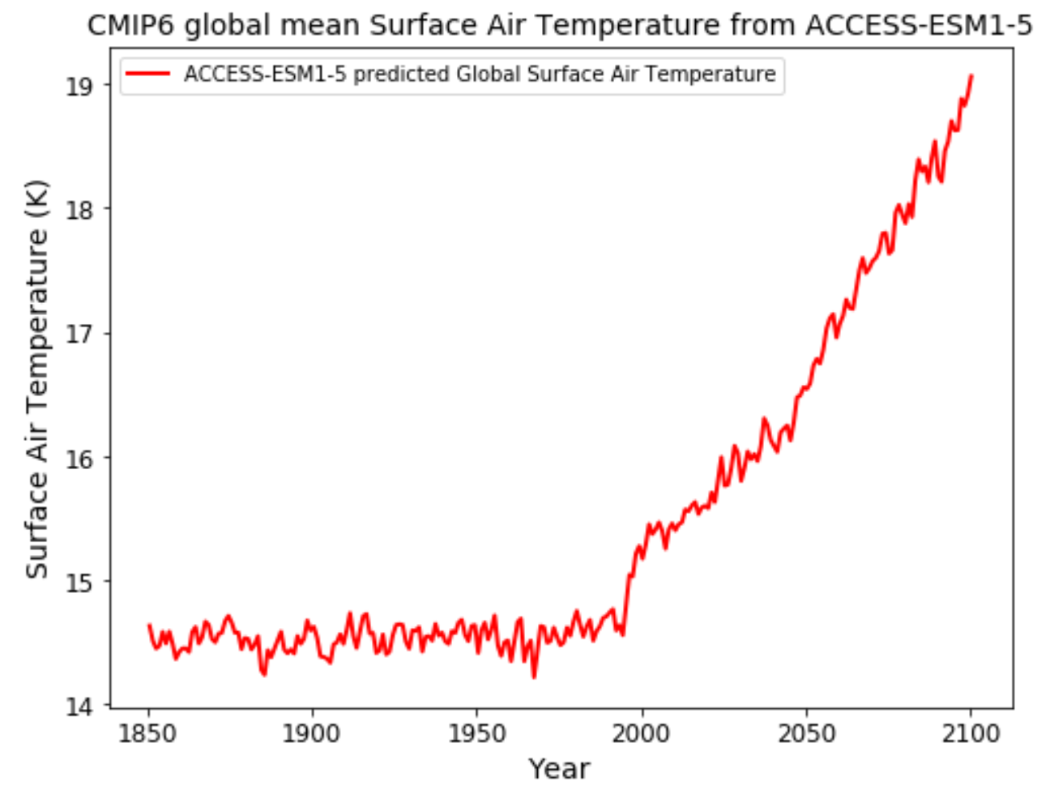

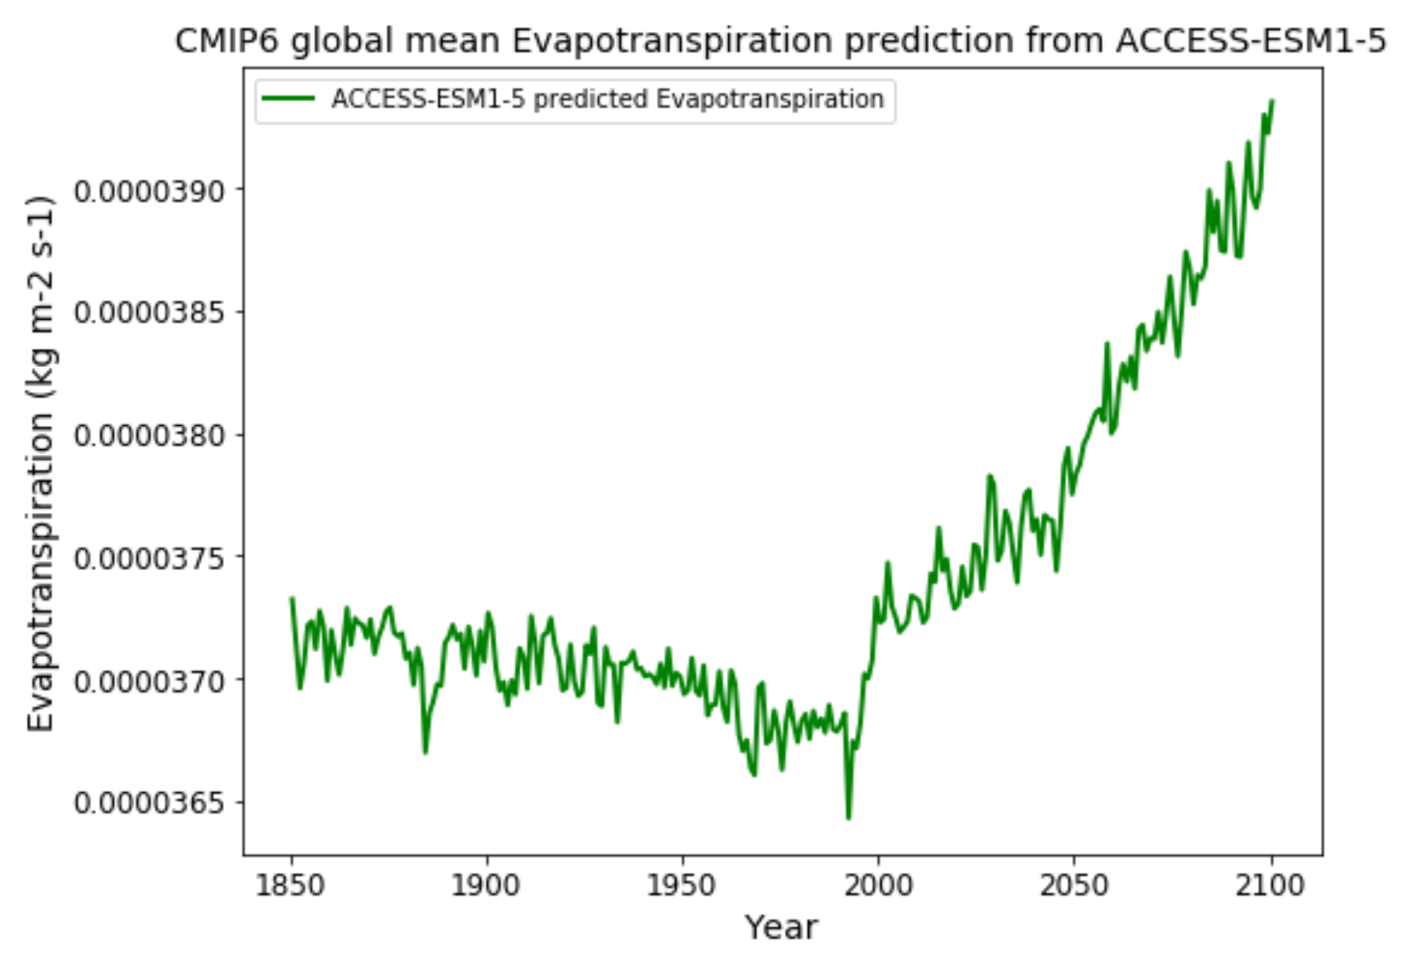

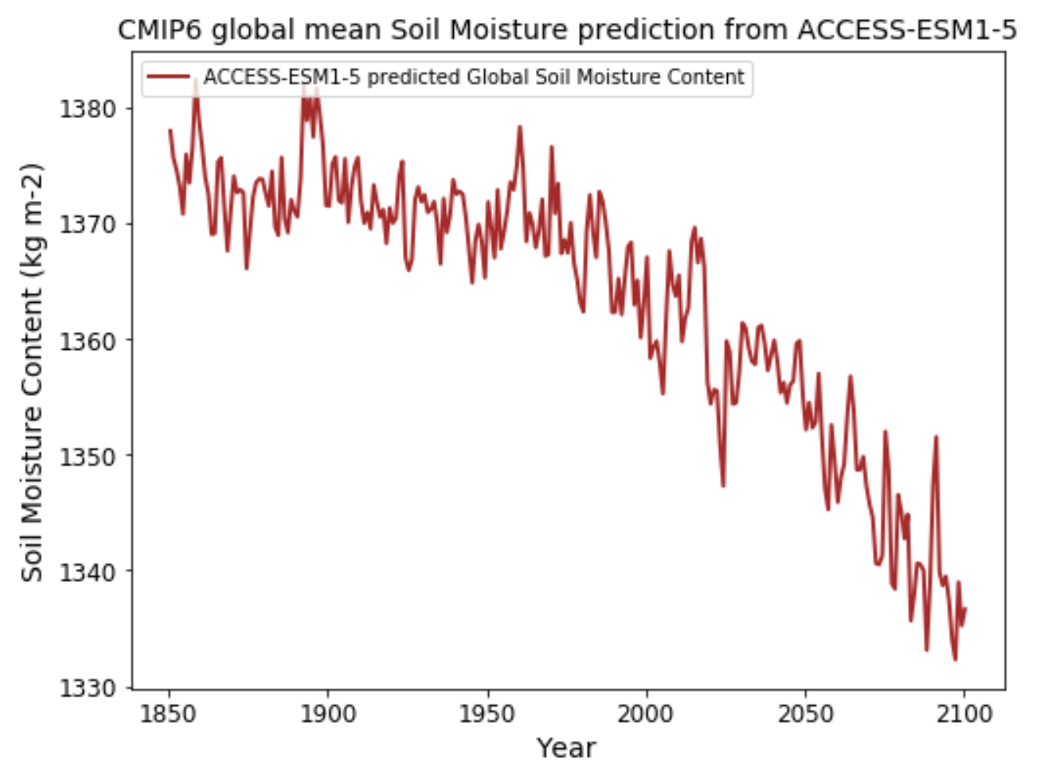

The time series above shows that surface air temperature started increasing drastically at the beginning of the century. Reasons for this is given by the economic development and rapid urbanization of many countries which led to an increase in demand for energy, food, and water. Increase in production of energy and food will cause an increase in GHG emissions which will cause global temperatures to increase. The increasing global temperature is also causing an increase in evapotranspiration rate. Plants will emit more water vapor as temperature increases. Some plants are also likely to perish in such high temperatures. Both increase in temperature and evapotranspiration rate is causing a decrease in soil moisture content. Higher temperature will cause a higher evaporation rate of moisture from soil and transpiration from plants, which get water from soil.

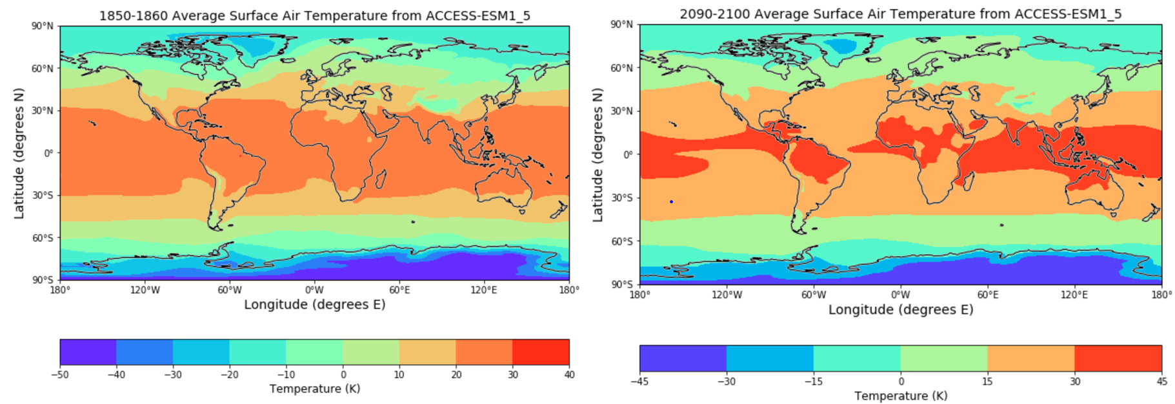

The map above shows the average of global temperatures for the timelines 1850 to 1860 and 2090 to 2100. Globally, every area experiences a change in temperature. The equator will experience the most warming.

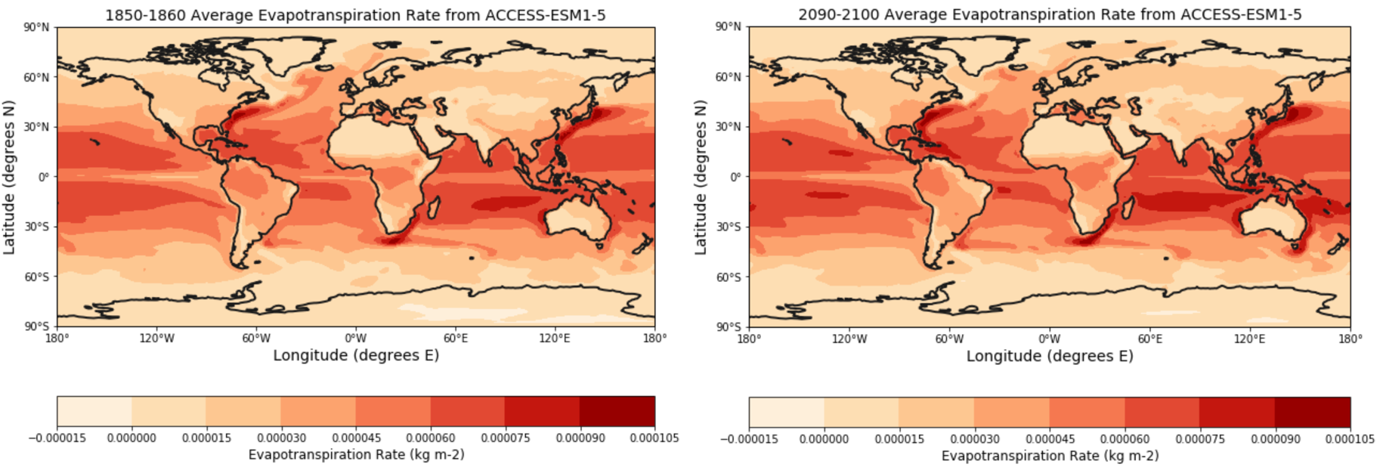

The map above shows the average of the evapotranspiration rate for the timelines 1850 to 1860 and 2090 to 2100. The maps show that the oceans will experience more evaporation than land. Evapotranspiration will increase for a few countries such North America, Africa, and Asia. Evapotranspiration decreases in Australia and South America.

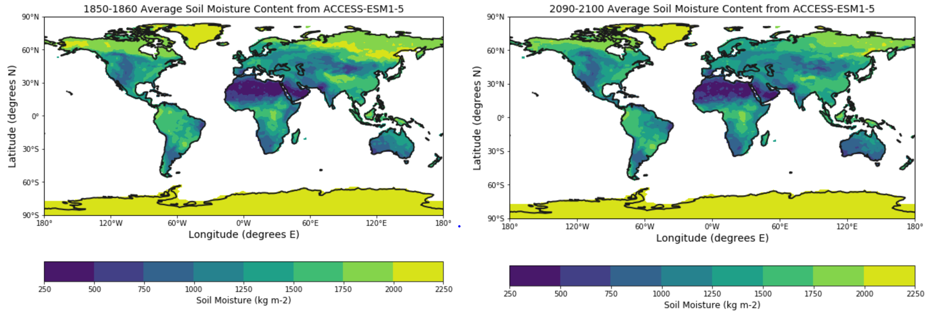

The map above shows the average of soil moisture content for the timelines 1850 to 1860 and 2090 to 2100. Every region will experience decrease in soil moisture, except Greenland and Antarctica.

**Discussion and Conclusions**

The results from my analysis support my hypothesis. Looking at the timeseries it shows that surface air temperature will increase which will cause an increase in evapotranspiration rate, thus causing a decrease in soil moisture content. Many scientific literatures confirm the correlation between temperature and evapotranspiration.

Liu & Zhang (2013) found that increasing temperatures are correlated with an increase in evapotranspiration rates. Another study by Moratiel & et al. (2010) discovered that evapotranspiration rates experience the most change during the summer months (May, June, July, and August) and were least affected in the winter months (November and December). Another study by Swelam & et al. (2010) not only confirms the correlation between temperature and evapotranspiration but goes on to discuss the many factors which influence evapotranspiration. Increasing humidity and carbon dioxide are said to counteract the effects of increasing temperature by reducing evapotranspiration rates. Increase in temperature will cause an increase in evaporation from the oceans, thus increasing humidity (Swelam et al., 2010). This finding explains why some regions experience less evapotranspiration in the future, from my analysis. A study from Rosenberg & et al. (1989) shows similar findings. Increase in temperature is known to increase evapotranspiration rates; however, global warming is primarily caused by the increase in GHG emissions. Much of the GHG emissions are in the form of carbon dioxide from automobiles, powerplants, etc. Carbon dioxide is known to suppress evapotranspiration rates. Due to the increase in carbon dioxide, the oceans will be primarily affected by global warming, thus causing an increase in humidity (Rosenberg et al., 1989). A similar study done by Goyal (2004) shows the adverse effects of temperature on evapotranspiration. Goyal noted that evapotranspiration demand will increase by 14.8% with a temperature increase by 20% (Goyal, 2004).

A study by Lakshmi & et al. (2003) identifies the relationship between temperature and soil moisture. The relationship shows that as temperature increases, soil moisture will decrease (Lakshmi et al., 2003). Another study by Holzman & et al. (2014) discovers how increasing temperature and decrease in soil moisture can affect crop yield. The study shows how soil dryness can reduce crop yield (Holzman et al., 2014). Looking at the results from the analysis, soil moisture is decreasing year by year. If such a scenario is true in the future, it can affect crop yield outputs, thus severely exacerbating the state of food insecure regions.

Combining the findings of various scientific literatures and from my results, it is confirmed that global warming will have adverse effect on the environment. Due to population projections GHG emissions and demand for food, energy, and water will increase. Increase in GHG emissions will cause an increase in temperature and increase in temperature will cause an increase in evapotranspiration rates in some areas. The increase in carbon dioxide will decrease the rate of evapotranspiration rate in some areas. The combined effects of increasing temperatures and evapotranspiration will decrease soil moisture content globally. Decrease in soil moisture can severely impact the agriculture industry be decreasing crop yield. A decrease in crop yield will and increase in population will lead to food insecurity in many regions around the globe. Such an analysis is important since it describes how such projections can mainly cause problems with food security. Those who are food insecure will be affected the most since the increase in demand for food will cause an increase in prices for food, thus many people will not have the affordability for a financial diet. This analysis gives us an incentive to switch to alternatives to reduce the impacts of such projections.

**References**

<https://esgf-node.llnl.gov/search/cmip6/>

Cavanaugh, M. L., Kurc, S. A., & Scott, R. L. (2011). Evapotranspiration partitioning in semiarid shrubland ecosystems: a two‐site evaluation of soil moisture control on transpiration. *Ecohydrology*, *4*(5), 671-681.

Goyal, R. K. (2004). Sensitivity of evapotranspiration to global warming: a case study of arid zone of Rajasthan (India). *Agricultural Water Management*, *69*(1), 1-11.

Holzman, M. E., Rivas, R., & Piccolo, M. C. (2014). Estimating soil moisture and the relationship with crop yield using surface temperature and vegetation index. *International Journal of Applied Earth Observation and Geoinformation*, *28*, 181-192.

Hu, Z., & Islam, S. (1995). Prediction of ground surface temperature and soil moisture content by the force‐restore method. *Water Resources Research*, *31*(10), 2531-2539.

Lakshmi, V., Jackson, T. J., & Zehrfuhs, D. (2003). Soil moisture–temperature relationships: results from two field experiments. *Hydrological processes*, *17*(15), 3041-3057.

Liu, X., & Zhang, D. (2013). Trend analysis of reference evapotranspiration in Northwest China: the roles of changing wind speed and surface air temperature. *Hydrological Processes*, *27*(26), 3941-3948.

Moratiel, R., Durán, J. M., & Snyder, R. L. (2010). Responses of reference evapotranspiration to changes in atmospheric humidity and air temperature in Spain. *Climate research*, *44*(1), 27-40.

Rosenberg, N. J., McKenney, M. S., & Martin, P. (1989). Evapotranspiration in a greenhouse-warmed world: a review and a simulation. *Agricultural and Forest Meteorology*, *47*(2-4), 303-320.

Sandholt, I., Rasmussen, K., & Andersen, J. (2002). A simple interpretation of the surface temperature/vegetation index space for assessment of surface moisture status. *Remote Sensing of environment*, *79*(2-3), 213-224.

Swelam, A., Jomaa, I., Shapland, T., Snyder, R. L., & Moratiel, R. (2010, August). Evapotranspiration response to climate change. In *XXVIII International Horticultural Congress on Science and Horticulture for People (IHC2010): International Symposium on 922* (pp. 91-98).